Pulse Oximetry Screening for Critical Congenital Heart Disease (CCHD) in Newborns

Patient Population/Area Affected
All infants born in the state of Wisconsin

Pulse Oximetry (Pox) Screening Protocol
All infants born in the state of Wisconsin should be offered pulse oximetry screening for CCHD. This should be done between 24 and 48 hours after birth and coordinated with the collection of the newborn screening blood card.
- If early discharge from hospital (<24 hours) in planned, perform initial screen as close to 24 hours as possible.
- For out of hospital births where early discharge from birth care is customary, perform pulse oximetry screen at the 24-48 hour follow up visit
- Infants requiring oxygen to treat pulmonary disease should have screening deferred until after their pulmonary disease and need for supplemental oxygen has resolved. If weaning to room air prior to discharge is not possible, echocardiogram should be done, and Pox screening is unnecessary
- Pox screening is not necessary if an echocardiogram is done prior to intended CCHD screening

Pulse Oximetry (Pox) Screening Equipment
- Pulse Oximetry screening should be done using motion-tolerant pulse oximeters that report functional oxygen saturation and are cleared by the FDA for use in newborns.
- Disposable or reusable probes may be used
- Use manufacture-recommended pulse oximeter-probe combination
- It is best to perform test when baby is quiet and alert to avoid false positives due to deep sleep
- Measure saturation (SP0₂) on right hand and either right or left foot. These measurements may be done sequentially.
- Ensure good pulse waveform. Do not hold probe with your own hand.
- Observe good pulse waveform for at least 1 full minute
- Measure and record baseline oxygen saturation.
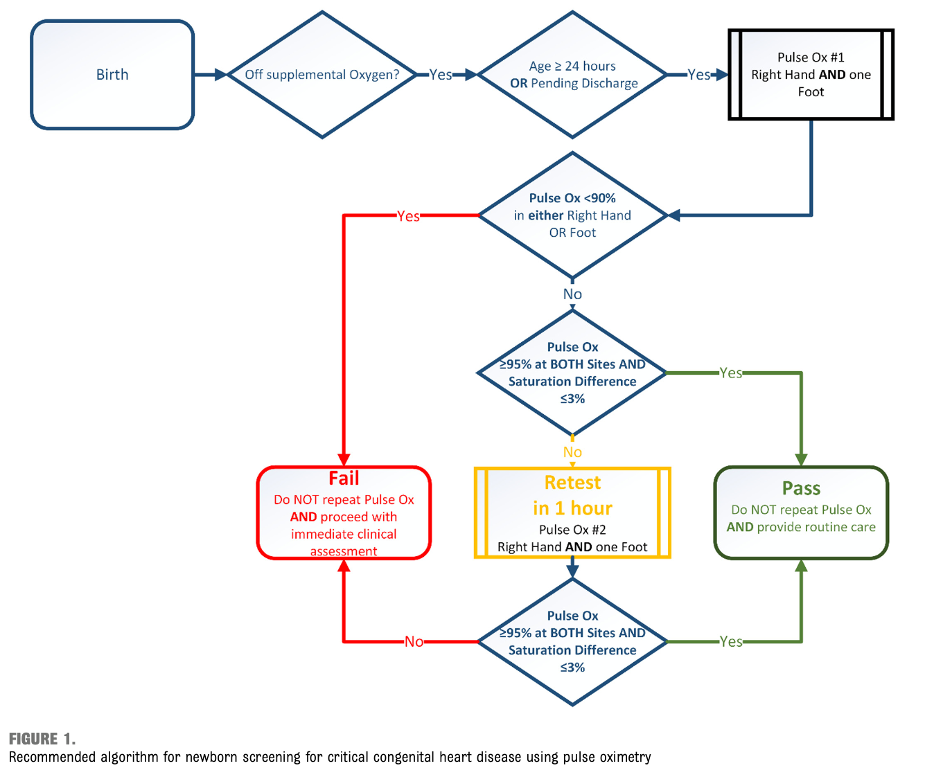

Screening Results
A baby may PASS, FAIL or require RETEST in 1 hour. A baby has two chances to pass their pulse oximetry screening.

First Screening:
Pass: SPO2 is ≥ 95% in right hand and one foot and there is ≤ 3% difference in SPO2 between right hand and foot: No further screening needed. Normal newborn care
Fail: SPO2 is < 90% in right hand or one foot: No further screening needed. Contact appropriate medical provider for further evaluation.
Retest in one hour: SPO2 is 90-94% in right hand or one foot and/or there is > 3% difference in SPO2 between the right hand and foot
- If signs of distress, contact appropriate medical provider for further evaluation
- If there are no signs of distress, retest in one hour

Retest:
Pass: SPO2 is ≥ 95% in right hand and one foot with ≤ 3% difference in SPO2 between right hand and foot: No further screening needed. Normal newborn care
Fail: SPO2 is less than 95% in right hand or one foot and/or there is > 3% difference in SPO2 between the right hand and foot Contact appropriate medical provider for further evaluation.

Response to a Failed Pulse Oximetry Screen
Infants who FAIL pulse oximetry screen require timely clinical evaluation. If a non-cardiac explanation for hypoxemia is not identified, CCHD must be excluded.
- Stabilize infant as needed.
- Contact appropriate medical care provider for clinical evaluation.

Documentation
- Results of the pulse oximetry screen should be recorded as PASS, FAIL, or NOT SCREENED on the newborn screening blood card.

Not Tested or Deferred Screening
Mark the box for NOT SCREENED on newborn screening blood card and check the appropriate box for why screening was not done:
- Deceased
- Declined
- NICU/O2
- Echo Normal
- Known heart disease
- Transferred
- Other

Screens that are deferred due to NICU/O2, transferred or other will populate into the WE-TRAC queue and CCHD results will be entered in WE-TRAC if and when available

How to Contact the Wisconsin SHINE Project
For immediate clinical concerns page the on call Pediatric Cardiologist at 1-608-262-2122
For technical assistance email us at wishine_info@pediatrics.wisc.edu

